**Is the problem well-articulated?**

**Who is impacted?**

* Customer - People usually order food at a restaurant and wait for a long time for the order to be processed. One of the main reason being the waiter is busy serving other people at the restaurant.
* Waiter - Only has the job of cleaning the table after food is eaten (So we can reduce the number of waiters or remove them entirely)

**Under which context (when, where, how, etc.) does the problem occur?**

* When there are lots of orders being taken, the use of drones increases the efficiency by automating the food delivery process to the customer.
* In most restaurant there are less number of waiters because of the cost, this causes issues such as the waiters not being enough to serve food for a lot of people.
* Also, serving a lot of orders results in fatigue towards the waiter.

**Consequences of the problem?**

* Customers end up waiting and lose a lot of valuable time
* Processing too many orders usually results in more errors
* More reliability of human resource, by reducing or eradicating the amount of work done by each person
* People also end up tipping the waiter even though they are not happy with the service

**Has the problem significance been discussed?**

* This problem usually occurs in fast food restaurants and our solution can overcome the delay in processing food as during rush hours, more time is spent in taking the food to the customers than preparing the food.

**Why do you care?**

* People end up spending more time waiting for the waiter to service when we go to eat at restaurant.
* People usually grow impatient when waiting for the food for longer than intended time

**Why shall we care?**

* It will minimize the human resource cost, the time required to serve the food and it will be an innovative way to deliver food to attract customers.
* It can increase the eating time because of the faster reaction service.
* Better Quality of Service.

**Related Work**

**What are solutions on the market?**

* In today’s restaurant service the most part is traditional way which is the customer make a order and the waiter get the items from kitchen and serve the customer. Besides there are some different way like some smart service system that use the machine to replace the human.
* For example, in some Japanese restaurant like sushi buffet there is the rotary equipment, the customers sit next to the belt and grab the food from the belt and after that put the dish back.  The other example is the use robot as waiters to send food from kitchen to the table.
* For the food delivery there is Yelp/Eat24 use robot to deliver food in San Francisco called as Marble and Domino use robot delivery pizza in Australia. Not only robot 7-Eleven has use commercial drone to delivery in the U.S.
* Yelp/Eat24 have a robot to deliver food called as Marble.
* Domino's uses a robot to deliver food in Australia.
* Amazon Prime Air - uses drones for door-to-door package delivery.
* 7-Eleven uses regular commercial door-to-door drone delivery service in the U.S.
* In countries like Japan, there are some restaurant that use robot to serve customer.
* DoorDash: It is an on-demand restaurant delivery service using Drones that fly with food to your house.

**How does user get around the problem now?**

* In today’s restaurant service the most part is traditional way which is the customer make an order and the waiter get the items from kitchen and serve the customer. Besides there are some different way like some smart service system that use the machine to replace the human.
* For example, in some Japanese restaurant like sushi buffet there is the rotary equipment, the customers sit next to the belt and grab the food from the belt and after that put the dish back.  The other example is the use robot as waiters to send food from kitchen to the table.
* For the food delivery to a person’s house, there is Yelp/Eat24 use robot to deliver food in San Francisco called as Marble and Domino use robot delivery pizza in Australia. Not only robot, 7-Eleven has use commercial drone to delivery in the U.S.
* To avoid waiting in the restaurant there are several ways that customers can use:

1. Pre-ordering food before reaching the restaurant
2. Ordering food as take-away.
3. An app like Opentable can make schedule of the arriving.
4. Go to some drive-thru restaurant like Mcdonald’s.
5. Some customer chose non-peak hours to go to restaurant.

**What are solutions discussed in the literature?**

* We found some technical support article. One is avoiding the collision during fly the other is self-localization and indoor position system. For the avoid collision system it’s use the fusion of ultrasonic (US) and infrared (IR) sensors to get relative position data and generate the attitude commands.
* As shown in the figure below, we use Ultrasonic, Infrared, Radio Frequency Identifier and multiple other sensors in conjunction with A- star algorithm, Estimote IPS and collision avoidance system for the drone to map and fly around the restaurant.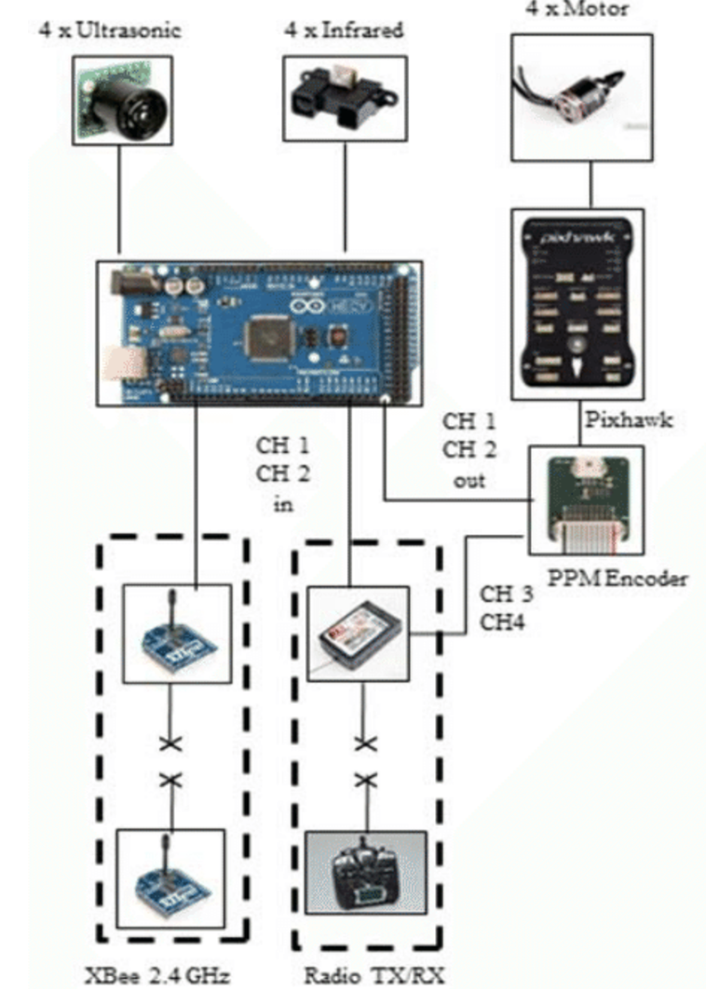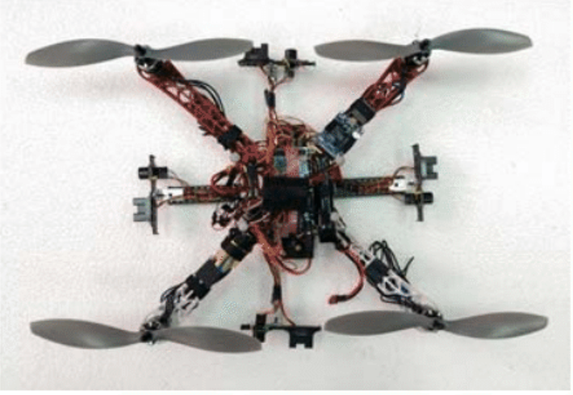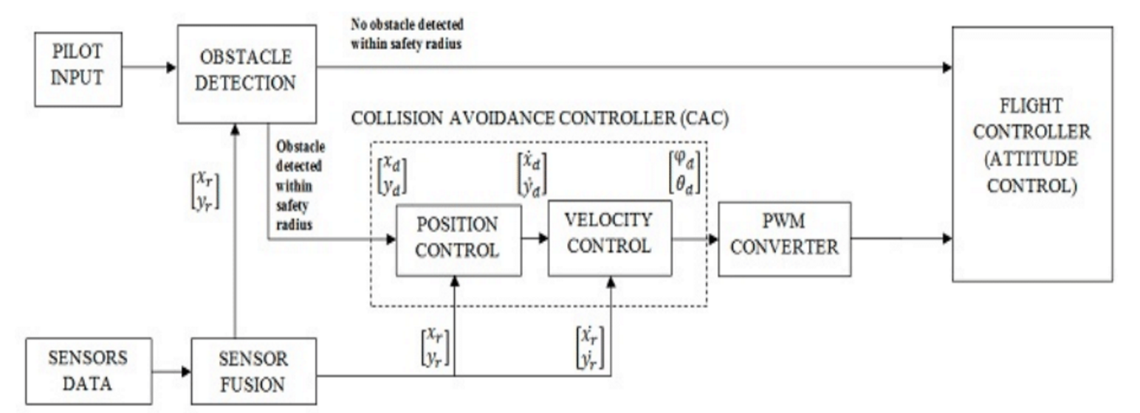
* And for the position we can use Wi-Fi or Bluetooth as the signal to navigate the drone and base on the indoor map and the presence of some unique markers to guide the drone to the particular destination besides use the A- star search algorithm find the path.
* For commercial drone used in restaurant the most important thing is the position of the drone. Here we can use Wi-Fi or Bluetooth as the signal to navigate the drone and base on the indoor map use the A-star search algorithm find the path.
* For example, through the indoor mapping system, we can treat each table as a node in the map and the drone can search the nodes on the map and find the path. Besides we need to avoid the collision here, therefore we use a fusion of ultrasonic (US) and infrared (IR) sensors to get relative position data and generate the attitude commands.

**What are the metrics to the ideal solution?**

* For the commercial drone the cost is most important thing. Because our proposed solution is the use of drone to serve the customers in restaurant so the important metrics are:

1. Battery time;
2. Speed;
3. Safety;
4. Path traversal;
5. Sound(noise);
6. Stability;

* Long battery time, Speed, safety, path traversal, sound
* The competitive analysis table is shown in the next page:

**Show the competitive analysis table**

|  |  |  |  |  |
| --- | --- | --- | --- | --- |
| **Factor** | **Drone** | **Robot** | **Rotary Equipment** | **Traditional(waiters)** |
| **Battery time** | 0.5-1hour | 10hours | Power outlet | - |
| **Speed** | 5 | 4 | 2 | - |
| **Path traversal** | Aerial | Ground | Table-based | - |
| **Cost** | $100-200/ea | $1000+/ea | $2000-3000 | $30000/year |
| **Reaction** | 5 | 5 | 1 | - |
| **Flexibility** | 5 | 4 | 2 | - |

Make appropriate citations

* Related work: Robots serving food within restaurants in China: <http://www.businessinsider.com/chinese-restaurant-robot-waiters-2016-7/#these-ten-robot-waiters-serve-customers-in-chengdu-china-carrying-dishes-around-and-giving-simple-greetings-to-customers-1>
* Indoor position system: <https://senion.com/indoor-positioning-system/>
* Collision Avoidance paper: <https://www.researchgate.net/publication/284724052_Relative_position-based_collision_avoidance_system_for_swarming_UAVS_using_multi-sensor_fusion>
* Collission Avoidance using Arduino based Ultrasonic and Infrared sensors: <https://create.arduino.cc/projecthub/anshulsingh163/drone-collision-avoidance-system-0b6002>
* Drone path-finding algorithm: A-star search algorithm: [https://en.wikipedia.org/wiki/A*_search_algorithm](https://en.wikipedia.org/wiki/A*_search_algorithm)
* Average delivery cost using a drone with existing solutions: <https://seekingalpha.com/article/3089766-amazon-com-heres-how-much-drone-deliveries-would-cost-per-delivery>

**Proposed Solution**

**If it is a hardware project, show the exact components and the cost**

Hardware Components:

* 3D Robotics X8+ - https://uavsystemsinternational.com/product/3d-robotics-x8/ - $1349.8
* RaspberryPi with button - http://uk.rs-online.com/web/p/processor-microcontroller-development-kits/8968660/ - $35
* Display - https://www.walmart.com/ip/Sceptre-E205W-1600/40718689?wmlspartner=wlpa&selectedSellerId=0&adid=22222222227029028326&wl0=&wl1=g&wl2=c&wl3=62007733248&wl4=pla-88446795168&wl5=9001901&wl6=&wl7=&wl8=&wl9=pla&wl10=8175035&wl11=online&wl12=40718689&wl13=&veh=sem - $69
* Amazon Fire Tablet - https://www.amazon.com/Amazon-Fire-7-Inch-Tablet-8GB/dp/B00TSUGXKE/ref=sr_1_1?ie=UTF8&qid=1493685367&sr=8-1&keywords=kindle+fire+7 - $49.99
* Internal Positioning System (IPS) and collision avoidance-
* Estimote - They are essentially tiny, low power computers attached to walls or objects in the physical world. Using proximity technologies, they detect human presence and behavior and trigger pre-programmed actions delivering contextual and personalized experiences.

Buy here <http://estimote.com/>

* Tera Ranger - TeraRanger One is the most advanced distance sensor for robotics. For crosstalk avoidance in multiple robot environments two versions of the sensor are available, type A and type B, which can operate simultaneously without affecting each other’s reading.

Buy here <http://www.teraranger.com/>

Software Components:

* A* Algorithm for shortest distance mapping

**Evaluation Methodology**

**What are the research questions to answer?**

* How the process of placing order takes place?
* Waiter/Manager takes an order.
* Customer has to come to place order on counter.
* Customer has to place order online.
* We have tablet on each table to place order.
* If your answer is a, How they write order?  
   a. In book  
   b. In tablet  
   c. They remember it
* If your answer is d, how does it work?
* Tablet are connected in network which gives a notification directly to kitchen.
* You have to collect tablet after customer places an order to check.
* if you answer is d, Why do you use tablet?
* What type of food you keep in restaurant?
* What is the average numbers of customers visit your restaurant everyday?
* What is the peak days and slow days in your restaurant?
* What are the peak hours and slow hours  in your restaurant?
* Distance between the ceiling and floor?

**How effective/accurate/effective does it work?**

* We are using Internal Positioning System (IPS) which is 90% accurate, we will make the routes fixed so it will increase the accuracy.

**If it is qualitative evaluation**

**What are the metrics?**

* We are evaluating using the following performance metrics:
  + Safety - The drone would be flying at a higher altitude thereby not affecting any person moving within the restaurant. The drone will also be equipped with collision avoidance system to detect other drones flying nearby
  + Time - The drone will fly on a speed of 5 meter per second which is faster than a person travelling towards the table, also the drone would be flying with the shortest distance measure thereby reducing significant amount of time when compared to the waiter.
  + Cost - The total cost would come around $7000, which includes 3 drones, display connected to RaspberryPi, Estimote IPS, TeraRanger for RFID and collission avoidance system and depending on the number of tables (termed to be 12 for 10 tables in this case), we can have appropriate number of tablets to operate in an easy scale.
  + Resources -
  + Scope  - The drone can scale across the whole restaurant in high altitude rather than a waiter moving through the restaurant to deliver the food..
  + Quality - The Drone should have good battery life and better weight lifting capacity.

What is the experimental design?

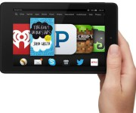 1.

Customer will place an order using tablet or device like tablet.

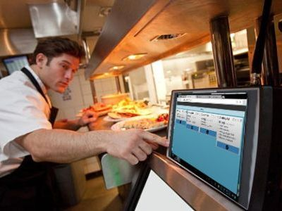

Chef/cook will receive the order directly in kitchen and he will place the food items on a drone.

2.

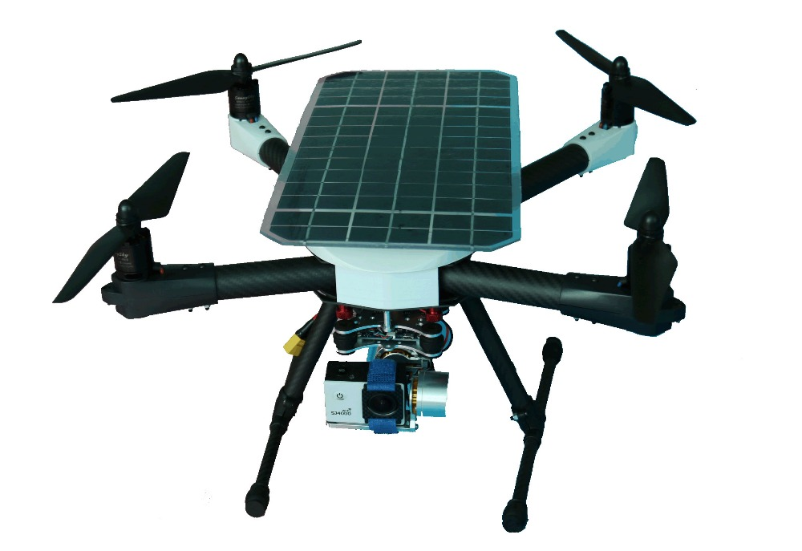

Drone will take the food to the respective table.

3.

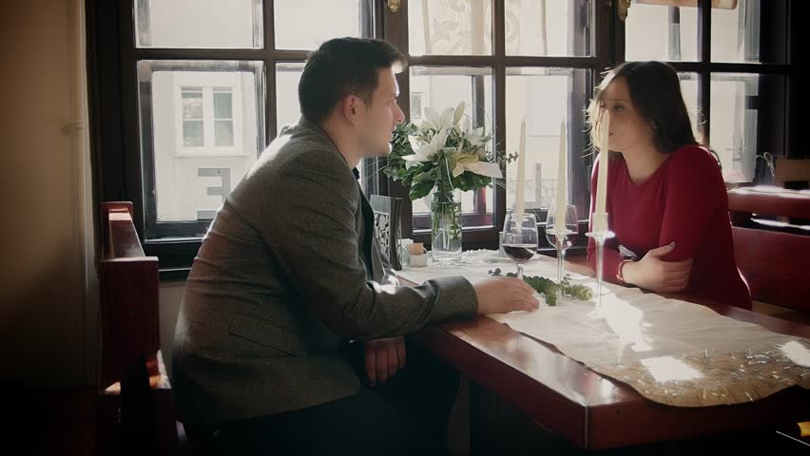

**Who are the target users? Where/how do you recruit them?**

* Restaurants and Pubs. We need not recruit people as this is an autonomous solution and does not require much interference from a person than just pressing a button to route the drone to appropriate tables with restaurant.

**How many do you need?**

* 3 - 4 drones

**What are the survey/interview questions?**

Restaurant owner:

1. How many waiters you have in a restaurant?
2. 1 – 3
3. 4 – 6
4. 6 – 9
5. 10 or more
6. How much do you pay to each Waiters?
7. How efficient your workforce in during peak hours?
8. How keen are you to make your restaurant more advance?

Customer:

1. How long do you have to wait after placing an order in a restaurant?  
   a. 5 - 10 minutes  
   b. 11 - 20 minutes  
   c. 21 - 30 minutes  
   d. 31 minutes or more
2. How much do you tip to a waiter?  
   a. 13% - 20%  
   b. 20% - 25%  
   c. 25% - 30%  
   d. 30% and above

**What are the usability testing tasks?**

1. Created a menu in tablet for customers to place order.
2. Using drone.
3. Placing order via tablet.
4. Synching order with the table.
5. Flying drones in Restaurant area.

**Video Link:**

https://www.youtube.com/watch?v=Yv4pV0X3gCk